# 

Manufacturing Technology Project

**ME3301**

**UNIVERSAL JOINT**

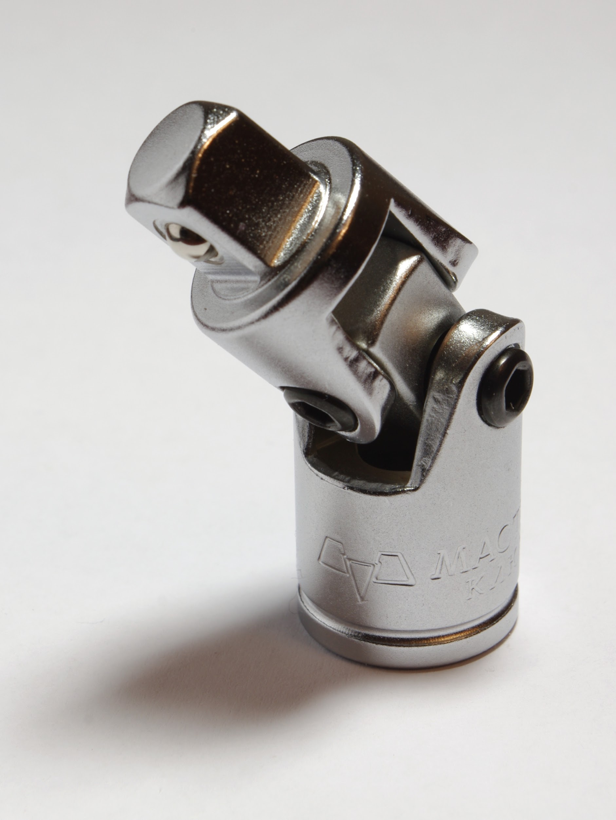

Group 5

K. Srivatsava - ME18B055

M.Vikash - ME18B057

J.Hrushikesh - ME18B049

**CONTENTS**

A. Classification:

1. Types of universal joints
2. Cross-type or spider and two yokes type or Hooke's Joints:
3. Ball and trunnion type:
4. Constant velocity type universal joint:

B. Advantages and Disadvantages

C. Purpose of the project

D. Performance and quality requirements

E. Material selection and property requirements

1. Main shaft assembly
2. Wobbler (Gearbox side)
3. Wobbler (Roller side)
4. Yoke assembly with universal joints
5. Yoke pin
6. Needle bearings
7. Roller
8. Spider Assembly

F. Manufacturing drawing with required dimension and tolerance

G. Manufacturing process selection and justification

1. Brief description of the drawings
2. Detailed description of the invention

H. Metrology equipment selection and justification

I. Cost estimation, Investment recommendation with Return of Investment

J. Conclusion

K. References

**ABSTRACT**

This report is mainly dedicated to an elaborate discussion of Universal joint or Cardan joint, which is widely regarded as the most important joint in the industry related to mechanical engineering systems and manufacturing domains. The significance and applications of Universal joints is discussed. Classification of these is also included. This report is mainly devoted to the study of Two-yorke type Cardan joints. The factors that affect the performance and quality of Cardan joints is analysed and the selection process of these joints in the industry is discussed, based on the application. The kinematic equations that fully describe the joint are derived using the analysis of mechanisms in order to understand its motion properties and uses. The idea of manufacturing of the component starting from the materials is given based on the properties. The possible dimensions and tolerances are also analysed. Best manufacturing process is outlined in detail and metrological analysis of the joint is also done. Finally, the cost analysis is done to make the process economically viable.

**THIS PAGE IS LEFT BLANK INTENTIONALLY.**

**Introduction:**

                      A universal joint (also called a U-joint or Cardan Joint) is a coupling connecting rigid rods whose axes are inclined to each other. It's commonly utilized in shafts to transmit rotation. It compensates the angular misalignment between the individual shafts in any direction. It consists of a pair of hinges oriented at 90° to every other, connected by a cross shaft.

                      The universal joint suffers from one major problem: even when the input drive shaft axle rotates at a constant speed, the output drive shaft axle rotates at a variable speed, thus causing vibration and wear. So, It is not a constant-velocity joint. Universal joints have been extensively used in applications such as automobile driver trains and aircraft control mechanisms.

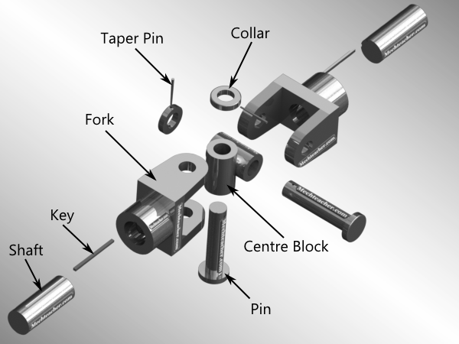 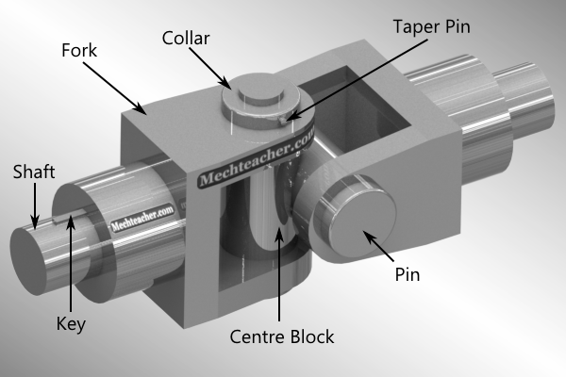

Fig 1.1 & 1.2: The exploded and assembled views of a U-joint.

**A. Classification:**

**Types of universal joints:**

1. Cross-type or spider and two yokes type or Hooke's Joints:

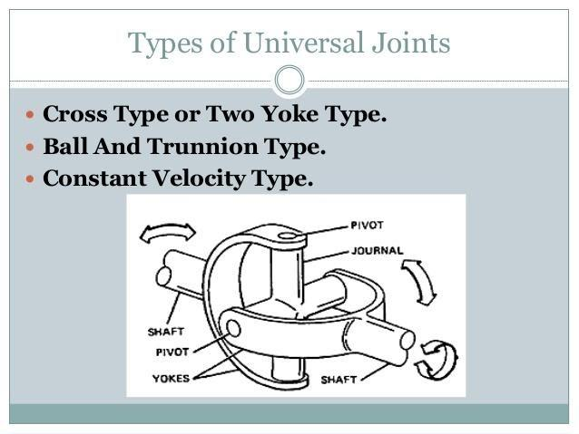

This joint consists of the crosspiece or spider and two yokes and because of these parts it is known as cross-type or spider and two yoke type universal joints. There are four-needle bearings one for every trunnion of the spider; the bearings are held in situ by rings heat drop into undercuts within the yoke bearings

Fig A1

2. Ball and trunnion type:

The ball and trunnion type universal consist of a ball head mounted to the highest of the propeller shaft through which a pin is pressed. 2 steel balls match over well the terms of the nail in order that once the assembly (ball head, pin & balls) provides into the body. The balls retain the roller bearings between them and u-shaped channels within the body.

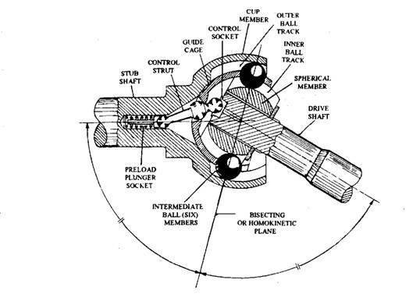

Fig A2

3. Constant velocity type universal joint:

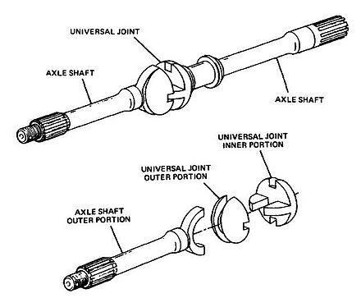

                          This is a more uncommon type. It comprises two individual universal joints connected by a ball and socket. The ball and socket split the finish of the two propeller shafts between two universal joints. This kind of joint grants uniform on the grounds that the two bones are working at a similar point, the acceleration coming about at any moment from the activity of one universal joint is counterbalanced by deceleration of the other and the other way around.

Out of these types, the most commonly used type is Cross-type or spider and two yokes type or Hooke's Joint. We shall analyse only this joint in this project. So, we refer to it simply as U-joint in the rest of this report, unless otherwise mentioned.

  Fig A3

**B. Advantages and Disadvantages:**

Universal joint is probably the most important mechanical joint, due to its wide range of applications. To mention only a few, the advantages of using these are in

* Driveshafts
* Automobile propeller shafts
* Stone crushers
* Tapping machinery
* Centrifugal blowers
* Centrifugal fans and centrifugal pumps
* Belt conveyors
* Control mechanisms
* Marine equipment
* Metal forming machinery
* Sockets

However, as with any device, there are also few disadvantages of this joint.

1. The non-constant velocity ratio causes the vibration and wear.

2. Shafts must lie in the same plane precisely.

3. Backlash is difficult to control.

**C. Purpose (Motive) of the project:**

              The aim of this project is to identify a suitable method to manufacture the Universal joint shown above that meets the quality and performance requirements. Also, we will suggest an estimate of cost and return of investment strategy to produce U-joints on a small batch (about 100). The energy consumption and pollution should also be minimum. Considering all these aspects, after some research, we have selected a suitable process.

**D. Performance and quality requirements:**

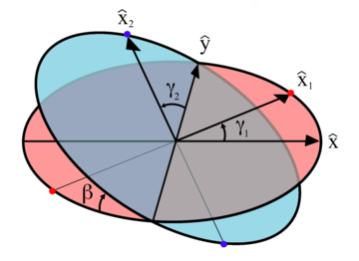

Fig D1

β the bend angle of the joint, or angle of the axles as for one another, with zero being equal or straight through. γ1 and γ2 are angles of rotation for axles 1 and 2 respectively. The common y- axis is the line of intersection of cross sections of both axles. The suffix 1 stands for input shaft and 2 stands for output shaft.

The angular position of the rotation axle 2 is given by:

γ2= tan-1()

The angular velocity of the rotation axle 2 is given by:

ω2=

For the case of the U- joint operating with a constant input speed, driving yoke plane coinciding with the plane of shafts and ignoring inertial considerations of the shafts, the relation between input torque T(in) and output torque T = T(out) is

T (in) =

The performance, quality and durability of U-joint mainly depends on angle of operation (β), rotational speed (RPM) of output shaft and transmitted torque T (out). Bending stress increases with the combination of these three effects. Excess torque may result in fracture, while high RPM results in wear and heat generation. The maximum angle of operation (β) is usually determined by the purpose of the joint. In automobile drive trains and aircraft control, the joint angles tend to be small, usually less than 10 degrees. Recently, universal joints have been used in medical instruments for the insertion of bone screws where the joint angle can be as high as 45 degrees.

Quality affirmations and prerequisites frequently require the best expectations for universal joint manufacturing – particularly in the medical and aviation fields. Commonly, the medical and aviation fields require quality systems that are identical to AS9100 or ISO9001 guidelines. AS9100 takes the ISO 9001 requirements and supplements them with extra recording and detailing necessities, which are set up by the aerospace industry, to fulfil DOD, NASA and FAA quality necessities for flight critical applications.

There exists recorded data to select U-joint based on these factors. It consists of curves called performance curves which are plotted between Transmitted torque and RPM working angle factor, which is the product of RPM and the working angle. This gives the joint size for best quality and performance.

Selection of a suitable curve is as follows:

1. For the continuous operation, choose the point that gives 2 times transmitted torque on Y-axis and working angle factor on X-axis. Based on this, select the suitable curve.

2. For the intermittent application, choose the point that gives the transmitted torque on Y-axis and working angle factor on X-axis. Based on this, select the suitable curve.

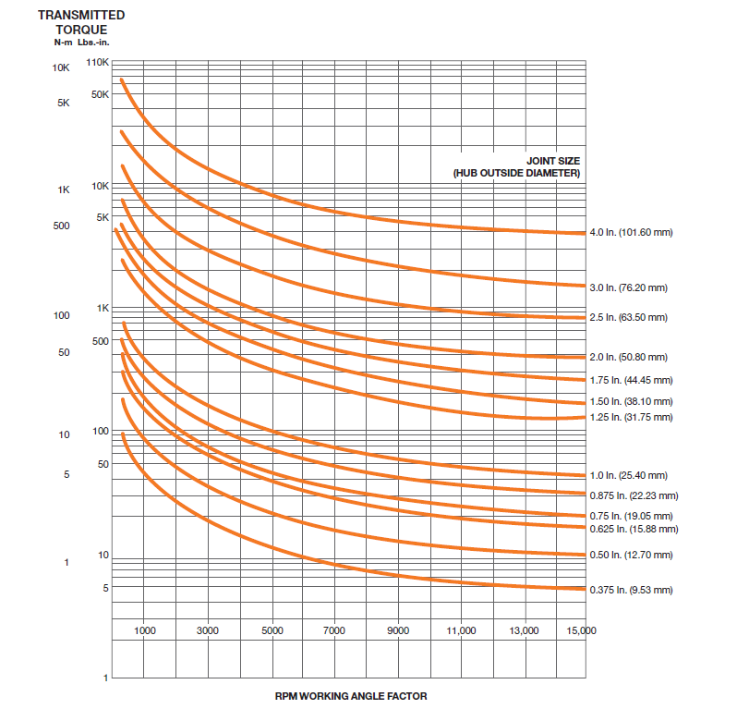

Fig D2

**E. Material selection and property requirements:**

**1. Main shaft assembly:**

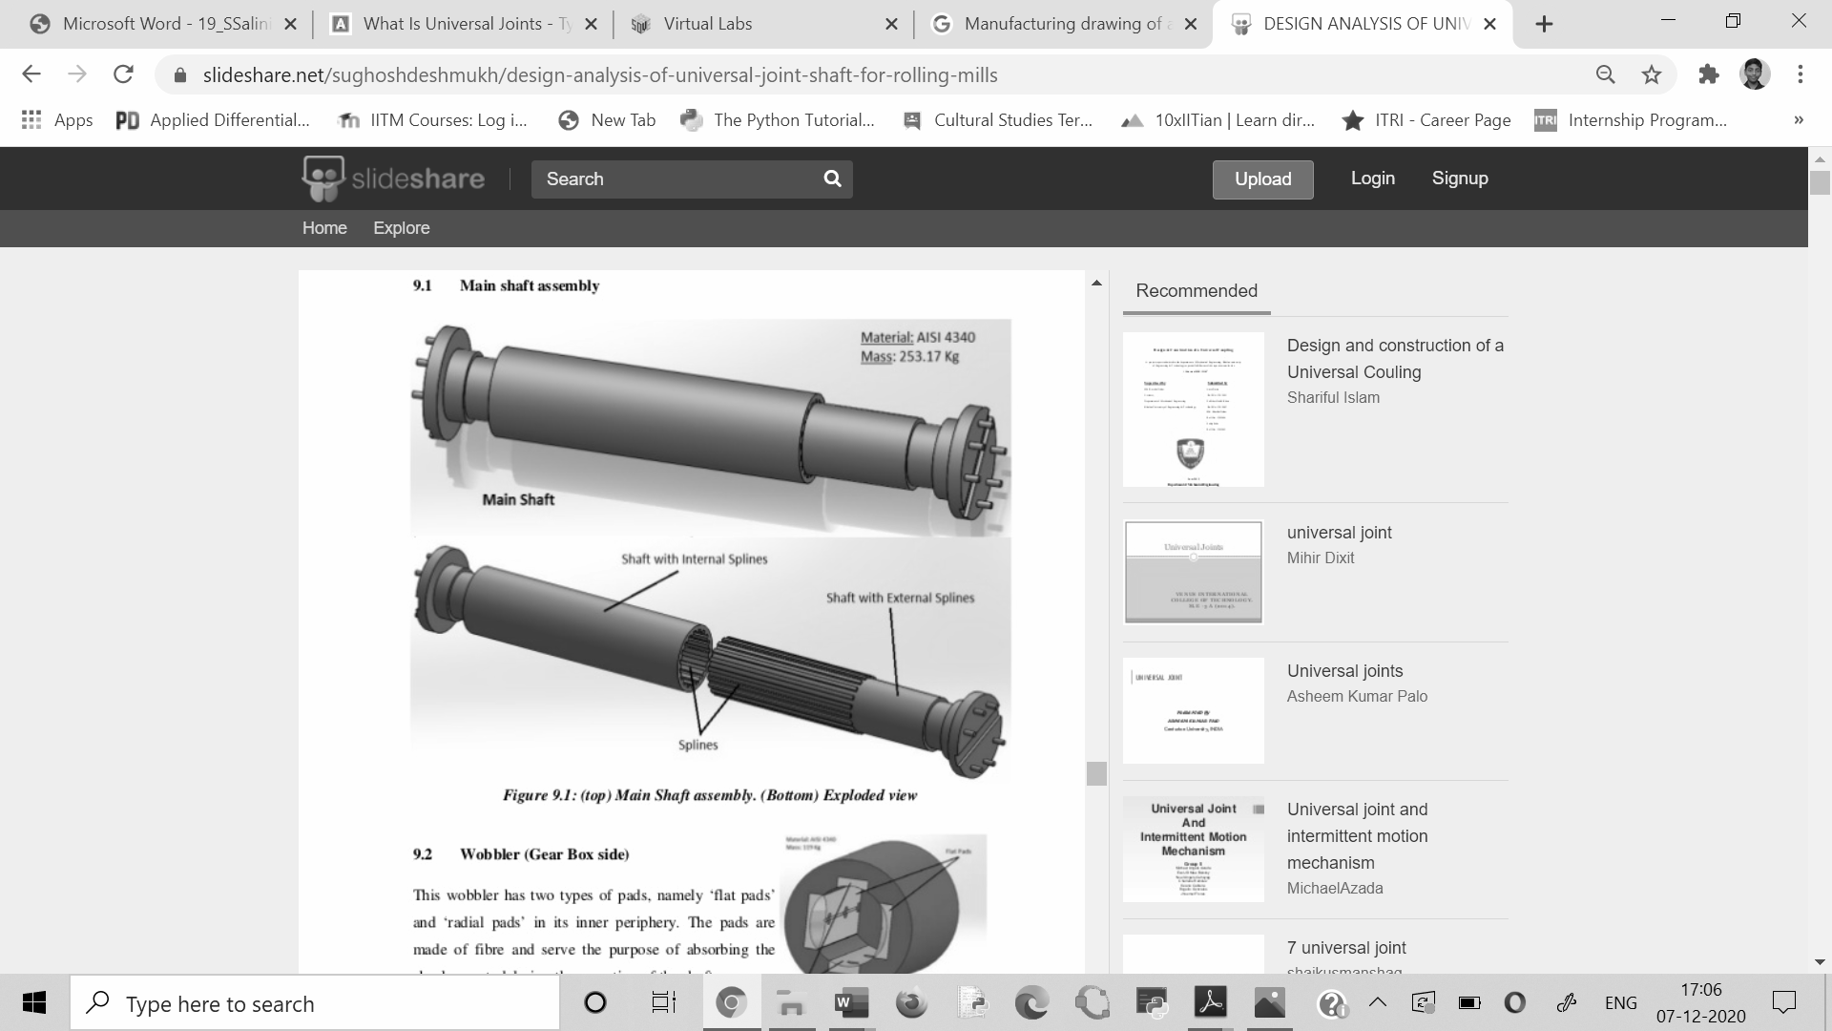

Fig E1

**2. Wobbler (Gearbox side):**

CHAPTER 09 CAD MODEL OF SHAFT AND OTHER PARTS
The Input CAD Model of the Shaft assembly has been designed using SolidWorks...

Fig E2

This wobbler has two types of pads, namely ‘flat pads’ and ‘radial pads’ in its inner periphery. The pads are made of fibre and serve the purpose of absorbing the shocks created during the operation of the shaft.

**3. Wobbler (Roller side):**

9.3 Wobbler (Roller Side):
This wobbler is similar in construction to its gear
box counterpart, the addition being that it...

Fig E3

This wobbler is similar in construction to its gear-box counterpart, the addition being that it has a ‘locating pin’ which fits in a similar groove in the roller. This ensures that there is a perfect alignment between the roller and the shaft.

**4. Yoke assembly with universal joints:**

9.3 Wobbler (Roller Side):
This wobbler is similar in construction to its gear
box counterpart, the addition being that it...

Fig E41

This assembly consists of split eye- type yoke assembly, eye plate-type yoke assembly and spider assembly compromising of bearings. The full exploded view is as shown below:

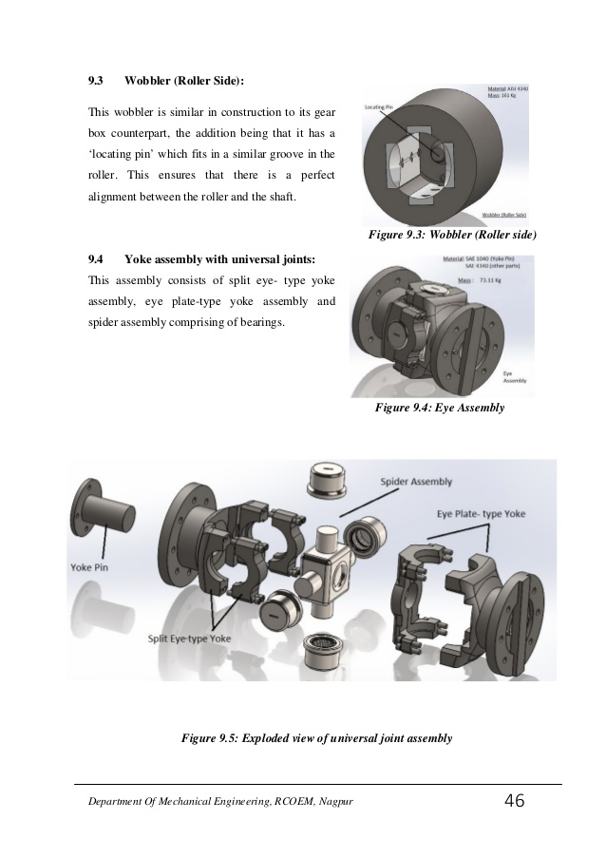

Fig E42

**5. Yoke pin:**

9.5 Yoke Pin:
The yoke pin is the main focus of this project. It is
fitted inside the hole in the split eye- type yoke and...

Fig E5

The yoke pin is the main focus of this project. It is fitted inside the hole in the split eye- type yoke and extends up to the slot in the eye plate. Its main function is to restrict the angle made by the universal joint thus, preventing the joint from damage.

**6. Needle bearings:**

9.5 Yoke Pin:
The yoke pin is the main focus of this project. It is
fitted inside the hole in the split eye- type yoke and...

Fig E6

The needle bearings used in this model are of grade IS 4215 RN1 - NB506225, meaning that the housing is of 50mm inner diameter, 62mm outer diameter and of thickness 25mm. The needle bearings itself are arranged in two rows, the specifications of the same being 6mm diameter and 17.5mm in height. The needle bearings are in direct contact with the spider arm (inner) as there are no inner races in the housings.

**7. Roller:**

9.8 Spider Assembly:
This assembly consists of a ‘spider’ which has four
arms on which four needle bearing housings are
mo...

Fig E7

The rollers are the most important components in any rolling mill. In this case, there are two rollers, which are set apart by a small distance; while the billet passes between them. The rollers are made from cast steel and have grooves on their surfaces. The curvature and the depth of these grooves depend on the application. The outer diameter of the roller is 360.5mm and its surface has 5 grooves in it.

**8. Spider Assembly:**

9.8 Spider Assembly:
This assembly consists of a ‘spider’ which has four
arms on which four needle bearing housings are
mo...

Fig E8

This assembly consists of a ‘spider’ which has four arms on which four needle bearing housings are mounted. Two of these housings fit into the split eye- type and the other two into eye plate type, which is mutually perpendicular to the split eye- type yoke.

Considering cost, strength and ease of manufacturing and access, Mild steel is selected as a suitable material.

The property requirements are as in the table below:

**Materials of various components Table E.1**

|  |  |  |  |  |
| --- | --- | --- | --- | --- |
| **Component** | **Material** | **Young’s**  **Modulus**  **(GPa)** | **Poisson’s**  **Ratio** | **Density**  **(kg/m3)** |
| Shafts | Steel | 215 | 0.3 | 7850 |
| Eyes and Plates | Steel | 215 | 0.3 | 7850 |
| Wobbler | Steel | 215 | 0.3 | 7850 |
| Yoke Pin | Steel | 215 | 0.3 | 7850 |

**F. Manufacturing drawing with required dimension and tolerance:**

Initially, manufacturers used to consider only the internal interferences to optimize the quality and performance of the U-joint, while ignoring the fact that manufacturing tolerances also affect its performance.

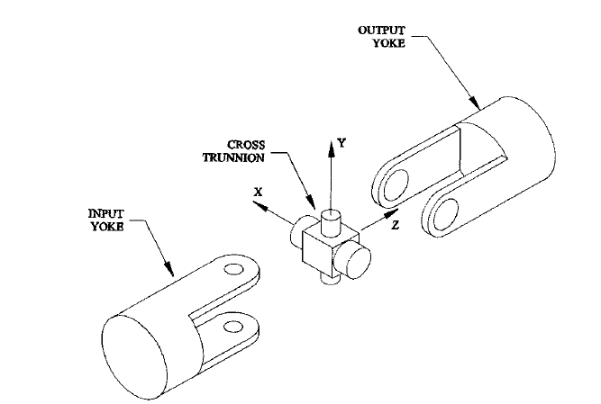

Fig F1. Axes and convention

Manufacturing tolerances have been shown to cause sliding at the pin joints and produce changes in the theoretical motion of the joint. This in turn increases the potential for contact to occur between the input and output yokes. However, design criteria are not readily available in any of the current design guides to address tolerance related issues in Universal joints.

We will develop the methodology and derive the relationships necessary to optimize the geometry of universal joints with manufacturing tolerances while checking for geometric interference between the various components.

**Manufacturing drawings:**

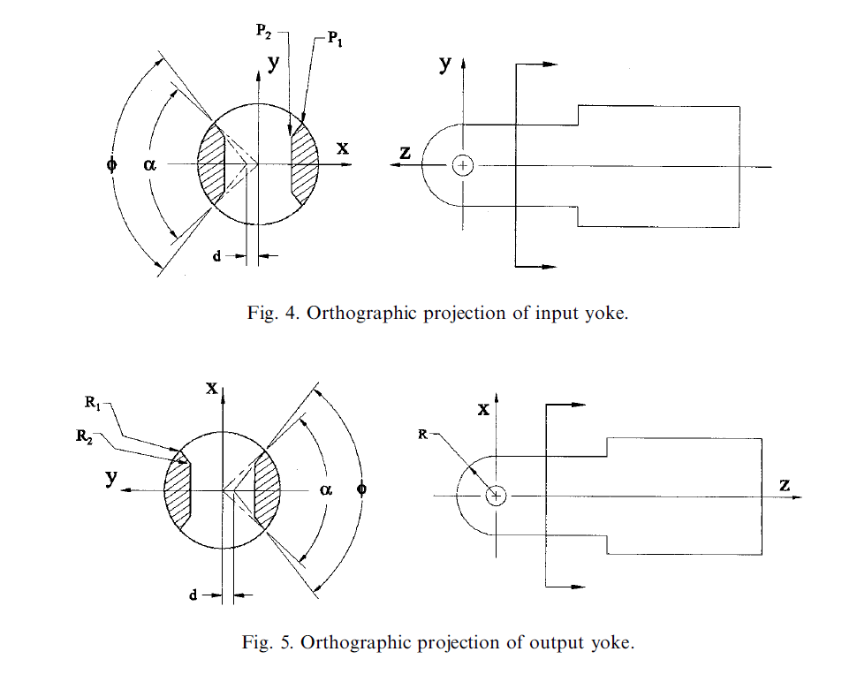

Fig F2



Fig F3

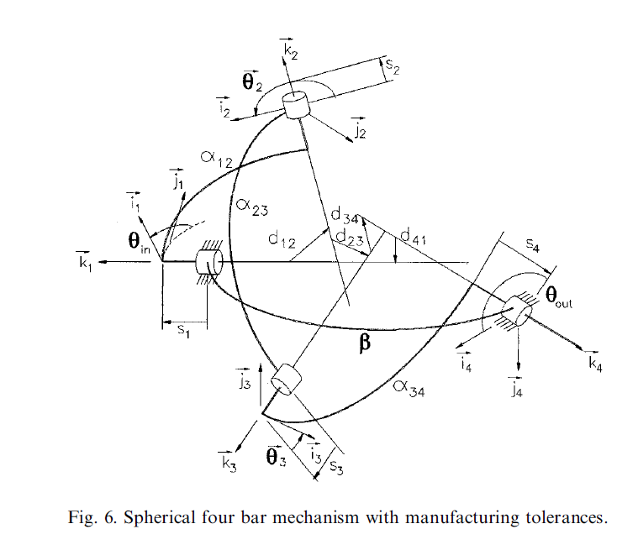

Fig F4

Firstly, the outside diameter is to be minimized for a given input torque and joint angle. To this end, the universal joint kinematics are based on a spherical four-bar linkage formulation which takes into consideration manufacturing tolerances. Relationships which describe the geometric interference between the various components have been derived by imposing the equations of motion of the spherical four-bar mechanism on the universal joint geometry being considered.

The input and output displacements are represented by y(in) and y(out) respectively. The joint angle, β, is formed between the input and output axes.

The lead-lag interference is defined as the difference between the output angular displacement and the input angular displacement. This can be written mathematically as,

L = θin-θout

At high joint angles the lead ± lag can become so large that contact occurs if adequate clearance is not provided between the yoke arms. A three-dimensional rendering of contact due to lead ± lag is shown in Fig. The interference volume created by the intersecting yokes is shown by the darkened region of the figure. This volume represents the three-dimensional space occupied simultaneously by the input and output yokes.

The extremely high forces which develop from contact and ensuing binding will cause joint

failure. Therefore, contact must be avoided at all times by designing the input and output yokes to handle the largest lead ± lag for a given joint angle, β. To this end, the magnitude of

maximum lead ± lag must be determined. The angular position of the output yoke is given by:

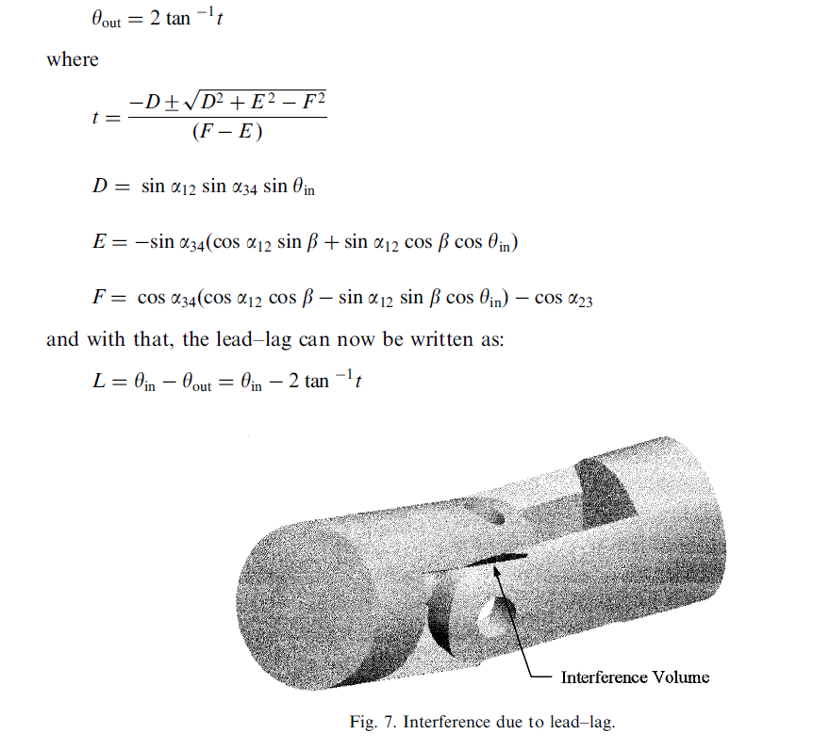

Fig F5

This expression can easily be maximized using the golden section method to determine the

maximum value of the lead- lag as well as the input displacement at which it occurs. As in

the ideal case, the universal joint under consideration is symmetric, therefore, the maximum

value of alpha, α, can be determined by summing the angles around the circumference of the

joint.

In addition to interference due to lead ± lag, contact can also occur when the radius on the

the end of one yoke arm touches the inside edges of the yoke arm adjacent to it. These edges are termed the edges of potential contact and this type of interference has been termed internal interference.

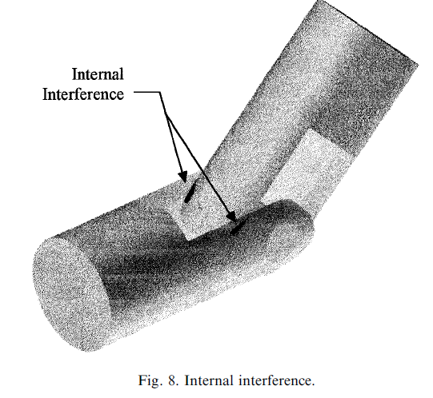

Fig F6. A rendering of internal interference

By inspection of the yoke geometry it is apparent that by decreasing ϕ and α, the interference can be eliminated. However, one should quickly realize that this would also sacrifice the strength of the joint, and in order to handle a given input torque the diameter of the joint would have to be increased to compensate for the decrease in ϕ and α. It is apparent at this time that the maximum allowable values of ϕ and α need to be used in order to minimize the diameter of the joint.

The locations of the edges of potential contact on the input and output yokes need to be

compared to determine if any points are coincident. If any points are coincident then the

design variables would need to be changed to eliminate the contact.

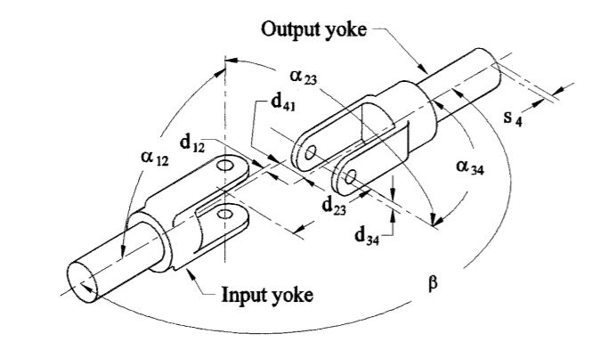

Fig F8. Pin and block type universal joint with manufacturing tolerances

Manufacturing tolerances effect the output of the universal joint by changing the output

rotation and by introducing an axial sliding term. The output angular displacement is given by Eq and the axial sliding, s4, is given below as:

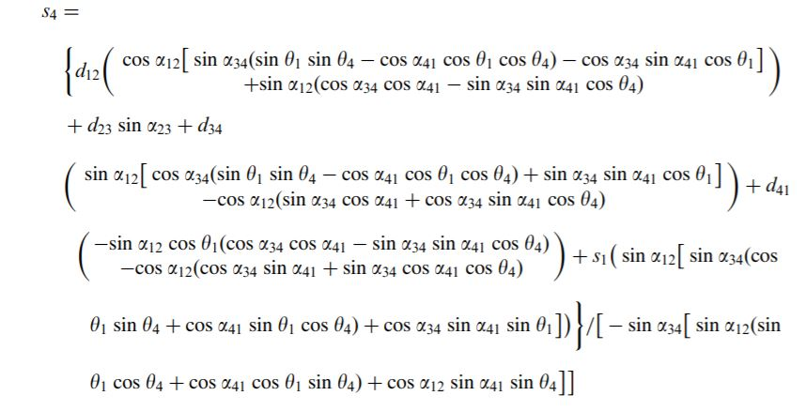

The final position of the output yoke of the actual universal joint can be found by ®rst considering the translation, s4, along the x-axis then the rotations yout about the x-axis, and b about the z-axis. The translation along the x- axis can be written as:

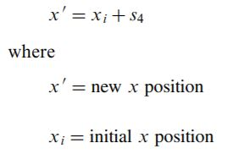

The rotation about the x- and z-axes can be represented by modifying the expression developed in for the ideal joint to include the eect of sliding outlined by Eq, in the form

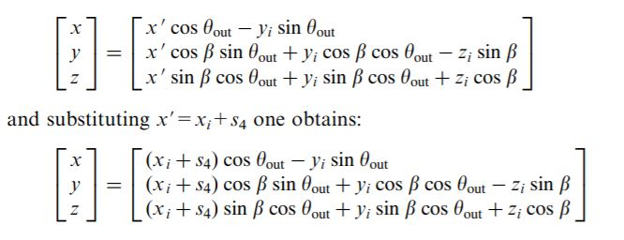

Above Equation is the final position of any point on the output yoke written in terms of the initial position. The overall shape of the yokes under consideration in this study is the same as the shape of the ideal universal joint considered by Hummel and Chassapis , therefore the initial position relationships previously developed can be applied here. Where

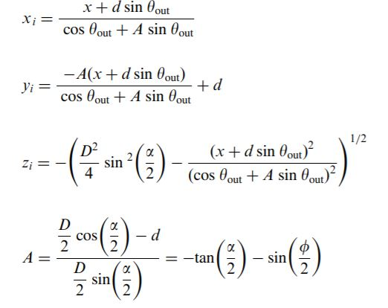

The equations for the initial positions can be substituted into the above equation to and the final y coordinate in terms of the final x-coordinate for the output yoke.

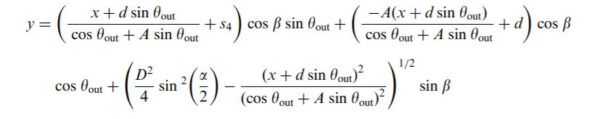

The final position of the input yoke is determined solely by the input angle, yin, and as such, the equations developed for the input yoke by Hummel and Chassapis can be directly applied. The final y-position in terms of the ®nal x-position for the edges of potential on the input yoke is given as:

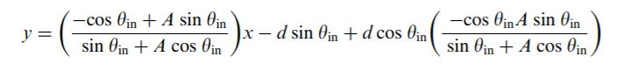

When interference exists, points on the input and output yokes are coincident. Therefore, to determine internal geometric interference one needs to equate Eqs:

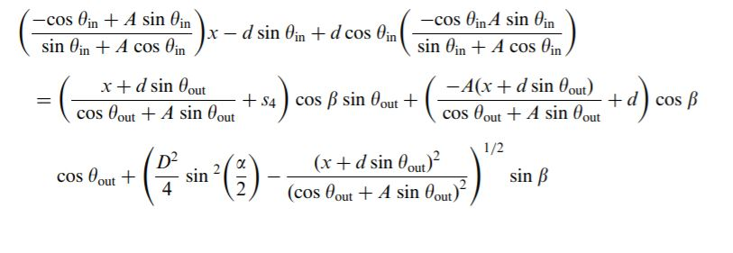

The elements of the above equation are related to the actual components of the universal joint through the coordinate system description given in Fig F.8. All of the tolerances shown in Fig can be readily quantified during the design phase. The magnitude of the tolerances will depend on the manufacturing processes used to produce the components of the joint. The existence of interference would have to be checked for every combination of tolerances to ensure clearance. This includes checking the maximum and minimum value of every tolerance.

The offset tolerance d, the distance between the input and output yoke centrelines, can be easily minimized using good design practice. If the input and output shafts are assembled on bearings the radial motion of each yoke will be close to zero. As long as the bearings are mounted in the same plane the input and output shafts will be in line therefore the offset distance d41 can be assumed to be equal to zero.

The angle and offset between the pinholes and the centrelines for the input and output yokes can be minimized using good manufacturing techniques. The yokes should be held in rigid fixtures during the milling process to prevent unnecessary rough finishes. Cross holes should be center-drilled prior to drilling to ensure accurate location. Additionally, holes should be reamed or honed to their final size. If care is taken during the manufacturing process the tolerances of the angle and offset between the pin holes can be assumed to be zero.

Diametrical clearance, however, between the pins and the holes in the yoke arms is necessary in order for the mechanism to operate. Naturally this clearance would contribute to the tolerances. The tolerances affected are the angle between the two pin holes, α23, and the offset distance between the two yokes, d23. Due to the nature of the mechanism it is virtually impossible to eliminate these two tolerances, and although tolerances can be minimized in

fabricating precision universal joints, they cannot be completely eliminated.

**Table.F. 1. Dimensions of Universal Joint (1310 series)**

|  |  |
| --- | --- |
| Joint angle | β=30o |
| Ideal joint dimensions | Diameter = 2.697cm or 1.0625 inch  Block width = 8.17cm or 3.219 inch  α=85.8o  ϕ=128.8o |
| Imposed manufacturing tolerances | α23=92o  d23=0.13 micrometer |

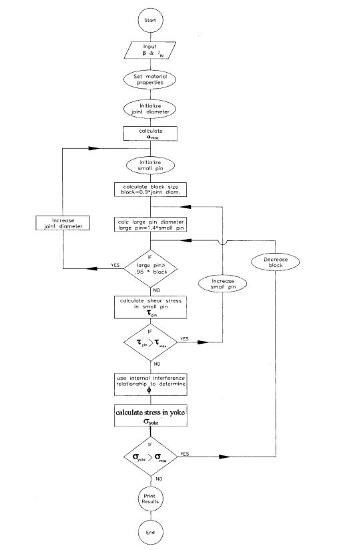

Fig F9 Universal joint optimization algorithm

An optimization algorithm is given in figure in the previous page, which depicts the procedure to minimize the diameter of a universal joint while ensuring that interference does not exist. The equation of internal geometric interference for the joint with manufacturing tolerances was applied in conjunction with the optimization algorithm to the example at hand to determine the values of α and ϕ. It was found that by changing angles α and ϕ 83.7 and 133.6 degrees, respectively, contact can be avoided.

|  |  |  |  |
| --- | --- | --- | --- |
|  | α(deg) | ϕ(deg) | I(mm4) |
| Ideal joint  Actual joint  Percent change | 85.8  83.7 | 128.8  133.6 | 2.276  2.018  13% |

As one would expect, the moment of inertia of the yoke arms of the original ideal universal joint is different from the new actual universal joint. The moments of inertia for the ideal and

actual universal joints being considered are shown in Table. It is evident that the moment of inertia for the actual universal joint has dropped significantly compared to the ideal universal joint. This is due to the changes in α and ϕ that were determined by the optimization algorithm. These changes were necessary to ensure clearance between the input and output yokes. This clearly shows how the strength of the universal joint is adversely affected by manufacturing tolerances. Furthermore, it shows that the strength of the joint is very sensitive

to relatively small values of the tolerances α23 and d23.

An optimization algorithm and geometric interference relationships have been developed to obtain joint parameters that result in an interference-free joint design, for a given tolerance specification. Additionally, the illustrative example showed that geometric interference is very sensitive to manufacturing tolerances. Relatively close tolerances created relatively large

changes in the behaviour of the output yoke which have been shown to adversely affect the load bearing capabilities of the mechanism.

**G. Manufacturing process selection and justification:**

A process for manufacturing a universal joint mainly by cold forging is disclosed which comprises of: -

* A blanking step to punch out a blank having a pair of fork member portions projecting from one side thereof and a hub member portion out of a sheet metal or coiled sheet metal material,
* A press-working step to form bolt holes on the lug member portions and projections on the opposite side thereof by extrusion,
* A forming step to bend each root portion of each pair of fork member portions to bring them to a fixed height from the hub member portion,
* A primary bending step to form the hub member portion into a cylindrical shape,
* A secondary bending step to project the lug member portions in parallel to each other from said cylindrically shaped hub member portion after completion of the primary bending step, and
* A press-reforming step to straighten the configuration of the formed product after the secondary bending step.

The current innovation identifies with a process for manufacturing a universal joint by cold forging, and all the more especially to a process for shaping from one sheet metal a cylindrical hub to be connected to a revolving driving shaft and a couple of forks confronting each other to be connected to a cross-arm.

**BRIEF DESCRIPTION OF THE DRAWINGS**

The previous articles and focal points will be seen all the more completely by reference to the following specification taken regarding the accompanying drawings, where;

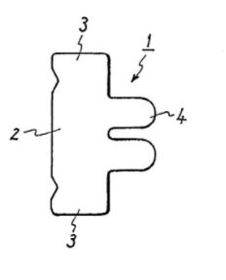

Fig. 1 is a plan perspective on the blank fabricated by conventional method,

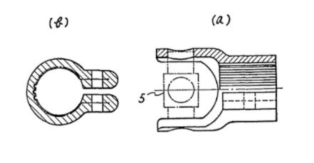

Fig. 2 (a) is a fractional sectional elevation view and



Fig. 2 (b) is a sectional elevation view on the hub made by conventional method separately,

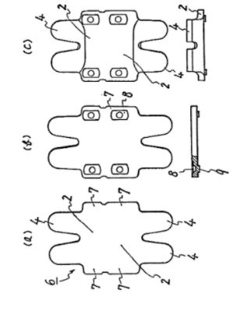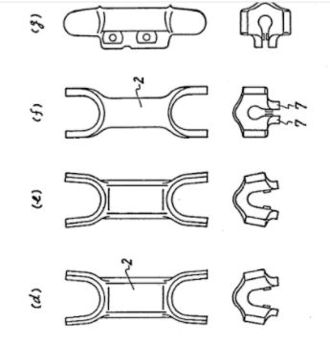

Figs. 3 (a) through (g) show individually delineations of cold forging process,

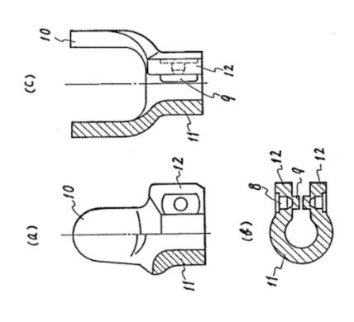

Figs. 4 (a) through (c) show individually representations of cold-forged product and its principal part, and

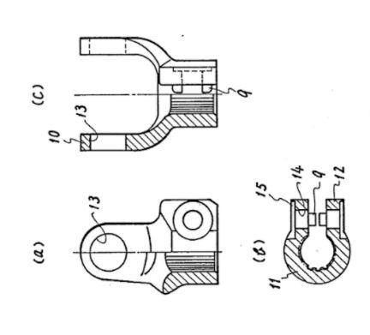

Figs. 5 (a) through (c) show individually delineations of cutting-processed end product and its principal part.

**DETAILED DESCRIPTION OF THE INVENTION**

It has been known in the earlier craftsmanship to make a universal joint from a sheet metal blank by exposing the equivalent to several manufacturing steps. For example, as in Fig.1 the universal joint has up until now been formed from a blank 1 which is made as a component of such universal joint as appeared in Fig.2 by punching it out of the sheet metal and involved a hub member portion 2 to shape a cylindrical hub, a couple of bending edge member portions 3 to shape lug portions adjoined to the two edges of the hub member portion 2 and jutted from the chamber to be darted to hold the center point in a tube shaped shape, and a couple of fork part parcels 4 to shape forks reaching out at the correct points from the center part divide 2 and interfacing with the two closures of one shaft of the cross arm components 5 for widespread joint. At that point, the center part is twisted to a cylindrical shape and its internal circumferential surface is spline-milled to make it conceivable to connect to the rotary driving shaft framed onto the spline shaft. Additionally, the lug parts to be shot are bowed to drill the jolt openings and secure the bolting.

However quite a conventional process unavoidably requires further two extra steps; one is to twist the bending edge member portions and another is to cut the thus bent-up edge portions not to prevent the spline milling. Moreover, since the bending edge part portions 3 must be added to the two edges of the hub member portion 2, the length of blank 1 normally turns out to be long and in result, taking a zone of fork member portions 4 into thought, a rate of material used in blanking step turns out to be impressively low. In this way in the prior art there were a few downsides with the end goal that few additional processes are required and that exercise in futility and material are achieved.

It is accordingly an impressive object of this invention to eliminate the defects of prior art as outlined above and toc provide an improved manufacturing process of the universal joint which is capable of reducing further the amount of processing step than conventional one through such methods as making it needless to hold out the heretofore performed bending work by forming the projections by extrusion process on each a part of the lug member portions so as to strengthen an equivalent and to make sure the tightening of an equivalent to clamp the hub, and further as making it needless to set a preliminary process for spline milling to be applied to the hub inner circumferential surface, while increasing a rate of material utilization by making the blank length smaller than that of conventional method, and furthermore as making a paired blank by abutting two blanks within the part of each edge of the hub portion.

The present invention will now be depicted in additional detail concerning the particular exemplification regarding the accompanying drawings.

In fig. 3, the blank 6 appeared on the diagram (a) is a paired blank which two hub member portions 2 and 2 are adjoined each other in one edge of their upper and lower parts. Likewise, the lug member portions 7 and 7 are longitudinally adjoined on the right and left edges of the individual hub member portions 2 and 2 in the said paired blank. Two sets of fork-member portions 4 and 4 are extended descending and upward from the separate hub member portions 2 and 2. In this model, however the blank 6 is combined to create two products all at once , there is no prevention in the resulting process regardless of whether the blank is organized to produce a solitary item at one time. The blank 6 might be punched out of a sheet metal or coiled sheet metal after spreading out its shape in such a state with the utilization of a suitable press machine. In the second step appeared in the diagram (b) of the same drawing, the bolt openings are framed on the lug member portions 7 and 7 and the bottom cavity 8 on the part where it fills in as a seat while bolting and simultaneously, the projections 9 and 9 are shaped on the contrary sides of said seat portions in order to guarantee said bolting. The projections 9 have almost a similar length in the upper and lower headings as that of the part filling in as a seat of bottom cavity 8. In the third step appeared in the drawing (c), the root edge parts of fork member portions 4 are exposed to a bending process to bring the stature thereof to a given length from the edge of hub member portion 2. This bending process must be completed for the motivations behind creating a space enough to connect the cross arm between two fork member portions 4 and 4 when bending the hub member portion 2 to a cylindrical shape. In the fourth step appeared in the diagram (d), the hub member portion 2 will be exposed to an essential bending process to frame it to a cylindrical shape. In the fifth step appeared in the diagram (e), a pressing process will be performed to fix the state of the workpiece after the essential bending process. In the sixth step appeared in the drawing(f), the hub member portion 2 will be exposed to an secondary bending process to carry it to a total cylindrical shape and simultaneously both lug member portions 7 and 7 are bent up to be extended with an almost equal connection to one another radially from the said cylindrically shaped hub. In the seventh step appeared in the diagram (g), the last pressing treatment will be made to spruce up the state of the semi-processed product after the secondary bending process in the sixth step. With this, all cold forging steps the press machine needs to do are finished. In like manner, cut out the thus formed product in two pieces at a fixed position thereof, the last cold forged item will at that point be obtained, as in Fig. 4.

In Fig. 4, a pair of forks 10 and 10 which are shaped by a bending cycle from the fork member portions 4 are organized to position inverse each other at a fixed stretch. The two edges of the round and hollow center point 11 holding the said mated forks 10 and 10 and shaped from the hub member portion 2 are situated to confront each other at one situation on the radially broadening line where the drag member portions 12 and 12 framed to be projected corresponding to one another from the center segment 11 by bending process are in like manner masterminded to position inverse one another. The particular projections 9 and 9 of both carry partitions 12 and 12 are also arranged to position face to face at a certain interval as required to form marginal space for bolting.

Referring at last to Fig. 5, a favoured cycle to drill the openings 13 on the forks 10 and 10 is in that delineated in which the cross arm might be pivoted. The inner circumferential surface of the hub 11 will be spline-milled to interface the spline shaft thereto. At that point, the bolt openings 14 will be bored on the lug part portions 12 by utilizing the bottom cavity 8 as a guide implies and the seats 15 will be similar shaped on similar bits. Along these lines, each part as the components of a universal joint is subjected to diverse processes and coordinated as a final product. Right now, however a center portion of the projection 9 distended from the lug member portions 12 might be shaved off because of the boring of previously mentioned bolt hole 14, the bolting and its tightening will be guaranteed on the grounds that the side portions are still left around the bolt.

As has been understood from the preceding elaborated description of specific embodiments the current invention is characterised by the subsequent benefits :

1) A reinforcement of the lug portion and a certainty of the bolting will each be earned by forming the projections on the same lug parts by subjecting an area of identical to extrusion method.

2) Since the same projections, as noted above, are shaped by subjecting a part of the lug member portions to extrusion method, it's possible to omit a bending process to bend the same portion as practiced within the previous art. The lug member portions to be fashioned at the blanking process will naturally be created tiny, so sanctioning the blank size to shorten lengthwise. consequently, once punching the blank out of the sheet metal a rate of material utilization will greatly be improved.

3) Since the projections of lug parts, as noted above, are fashioned by extrusion method to either side thereof facing one another with a bolt hole between, a posture of the lug parts once fastened is stabilised and in consequence the bolting itself becomes robust. This makes it attainable to connect the hub stably and precisely to the rotary driving shaft.

4) Further, consistent with a method of the current invention, many processing steps are often saved though a rather heavy sheet metal is utilized in a manufacture of this universal joint. for example, although the fork parts, in standard processes, are press-worked to create a touch concave configuration inward thereon therefore on increase a strength of the same portion, the current invention permits eliminating such an additional pressing work and assures saving of the amount of process step.

5) Moreover, the current invention provides a process to create a paired blank for users, thereby reassuring more effective production and sharp reduction in price than that of the previous art.

**H. Metrology equipment selection and justification:**

We use the concepts of Metrology of Surface finish and Form metrology here. The justification for this is that we need a process that ensures mass production and cost efficient. Form metrology ensures these because it allows mass-assembly of mechanical products because exact measurement of shape allows for predictable performance when bringing parts together in an assembly and is required to achieve a specific performance. Also, keeping form controlled to tight tolerances minimizes material waste in some cases this is the most important part of the product cost, which improves profits for manufacturing plants. This is done using CMM. Also, Metrology of Surface finish ensures that the surfaces are accurate.

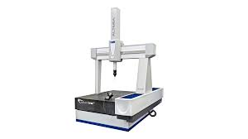

Fig H1

In surface finish, for Forging activity, the estimation of Centre Line average (Ra) limits are 2.5 to 25 micrometre. Since we embrace the forging process, we will utilize these limits. We utilize pneumatic methods for Yorke’s in light of the fact that the stylus technique isn't attainable. The air leakage technique is frequently utilized for evaluating surface texture. A pneumatic comparator is utilized for conducting mass examination of parts. Compressed air is released from a self-adjusting nozzle held near the surface being reviewed. Contingent upon stature varieties in the surface inconsistencies, the gap between the nozzle tip and the workpiece surface fluctuates. This outcomes in the variation of flow rate of air, which thus changes the rotation speed of a rotameter. Rotation of the rotameter indicates surface irregularities. Alternatively, a float can likewise be utilized to gauge surface deviations. The comparator is at first set utilizing reference gauges.

In form metrology, The CMM is an advanced gear, which offers gigantic adaptability and flexibility in present day manufacturing applications. It utilizes the fundamental principles of metrology to a degree that isn't coordinated by some other measuring instrument. In any case, its utilization is restricted to circumstances where production is done in small numbers yet items are of high worth. It is particularly valuable for components of varied features and complex geometry. Here we consider small batch production of 100 items and the components are profitable. Thus, it's the most ideal decision. \

A CMM is interfaced with the CNC machine so that machining is adjusted as the workpiece is investigated. A further expansion of this rule may incorporate Computer-Assisted Design and Drafting (CADD).

**I. Cost estimation, Investment recommendation with Return of Investment:**

We use Precision Forging. Precision forging is more costly than conventional forging, but the Savings in material and machining costs are significant, Forming complex shapes is possible and Precision forging represents a higher value product than a conventional forging (higher added value).

For Low alloy steels, the working temperature is about 250 degrees C. The average yield percentage is 85 percent.

**Cost of Raw Material:**

Diameter of joint = 2.6978 cm

Block width = 8.7162 cm

Volume of starting workpiece = 0.5xπ×(0.026978)2×0.087162= 9.964×10−5 𝑚3

Density of Mild Steel: 7850 kg/m3

Number of Parts required: 100

Mass of 100 parts:

Density × Volume × No. of Parts Mass of 100 parts = 7850 × 9.964×10−5 𝑚3 = 78.22 𝐾𝑔

Cost of Mild Steel per Kg = Rs 60

Total Cost of Raw Material Required = Cost per Kg × Total mass of 100 parts = 60×78.22=𝑅𝑠 4693.398.

**Cost of the Forging process:**

The volume of the forging should be calculated, for defining the volume of the material to remove. Surface area of the forging is required to be calculated, for obtaining the machining surface area.

tvolmill = V0 / Zv

Zv = ae * ap * Vf

tsurmill = S0 / Zs

Zs = ap * Vf

where,

V0 = volume of material to remove in mm3

S0 = surface area of the material to remove in mm2

Zv = metal removal rate in mm3 /min

Zs = surface rate in mm2 /min

ae = depth of cut in mm

ap = tool path interval (lateral depth of cut) in mm

Vf = feed speed in mm/min.

The calculated machining times are approximate, because the formulation does not include the time spent for the rapid movements of the tool. It is suggested to add a 15% percent additive time for correction from statistical methods.

tforg = 1.15 * (tvolmill + tsurmil).

Using these formula and the calculated value from the industry, the total time for process comes out to be 40.41 seconds for 1 item and 4041.23 seconds for 100 items.

The Power utilised by the forging appratus = 25 MW

So, the electric energy needed for 100 items = 25 x 4041.23 = 1010.376 MJ = 280.66 units.

Industrial cost of 1 electricity unit = Rs. 10

So, total cost for the process for 100 items = Rs. 2806.605

**Total Cost and Return on Investment :**

The total Cost for 100 items is 2806.605 + 4693.398 = Rs. 7499.98

The typical cost of a reasonably good quality U-joint in market (Online etc) = Rs. 95

The average cost in this production process as a whole per U-joint = Rs.75

So, this process is cost efficient. The Return on Investment(ROI) is 26.67 %.

**Carbon Analysis:**

Total carbon release in this method is about 10.44 kg of CO2. This is significantly better than in industries at present.

**J. Conclusion:**

In this report, the general principles of Universal joints are discussed. Classification of these is also included. This report is mainly devoted to the study of Two-yorke type Cardan joints. The factors that affect the performance and quality of Cardan joints is analysed and the selection process of these joints in the industry is discussed, based on the application. Motion of the mechanism is also analysed.

The idea of manufacturing of the component starting from the materials is given based on the properties. The possible dimensions and tolerances are also analysed. Best manufacturing process is outlined in detail and metrological analysis of the joint is also done. Finally, the cost analysis is done to make the process economically viable. The best possible method of manufacturing is chosen and the relevant analysis is done.

**K. References:**

[1] S.R. Hummel, Adjustable universal driver (1993), United States Patent no. 5,188,189.

[2] I.S. Fischer, Internal force and torque transmission in a Cardan joint with manufacturing tolerances. Eng.

[3] A.Y. Dodge, Automotive Industries 83 (1940) 636.

[4] H.I.F. Evernden, in: Proceedings of the Institute of Mechanical Engineers, Automotive Division, Part III,

[5] A.T. Yang, F. Freudenstein, Transactions ASME, Journal of Applied Mechanics 86 (1964) 300±308.

[6] F. Freudenstein, I.S. Fischer, Journal of Mechanisms, Transmissions, and Automation in Design 106 (1984)

[7] E.R. Wagner, C.E. Cooney, Universal joint and driveshaft design manual. Advances in engineering series No.

[8] J.E. Shigley, C.R. Mischke, in: Standard handbook of machine design, McGraw-Hill, New York, 1986, pp. 19±

[9] D.A. Lee, Machine Design 37 (1965) 151±153.

[10] Machine Design 11, 1939, pp. 47±48.

[11] K. Lingaiah, in: Machine design data handbook, McGraw-Hill, New York, 1965, pp.

[12] S.R. Hummel, C. Chassapis, Mechanism and Machine Theory 33 (5) (1998) 479±490.

[13] J.S. Arora, in: Introduction to optimum design, McGraw-Hill, New York, 1989, p. 298.

[14] <https://en.wikipedia.org/wiki/Universal_joint>

[15] Google Images